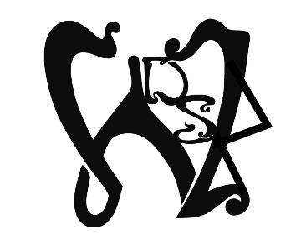
Willow Dragonstone Community & Coven, Inc.

General Member Agreement
I wish to join Willow Dragonstone Community & Coven, Inc. As a General Member I will:
- Understand that being part of community may mean that I will experience personal and spiritual growth and may require learning more about myself and the Craft.
- Participate as often as I am able understanding my absence energetically diminishes the community and my presence bolsters it.
- Accept and be inclusive to all people who are called to worship in this community. This includes all ages, genders, sexual orientations, sexual preferences, races, ethnicities, and relationship structures.
- Maintain a positive moral outlook and an ethical code of conduct. This positive moral outlook encourages and empowers other General Members to be their very best selves. The ethical code of conduct will encourage me to be my very best self.
- Cultivate relationships of cooperation, friendship, and respect with all general members. To that end I will not gossip unkindly about my community, the leadership or other General Members. I will keep the identity of other general members and friends confidential except with permission.
- Agree to take all grievances to the person directly involved and then to involve someone from the Family Coven or an elder if conflict persists. Further I know all successful relationships require that I do not hold against my community brothers and sisters perceived wrong doings. I cannot keep score. When I empathize with brothers and sisters of the craft whom I may hurt intentionally or unintentionally, I am manifesting emotional safety.
- Not physically assault my brothers or sisters in community. I understand consent is required in all sexual situations. I will safeguard all minors and persons who do not have the ability to grant sexual consent. I will not drink to excess at Willow events. All these things I vow to do to prevent a culture of consent toward violence and violation in word and deed. I understand the most prevalent violation can be spoken or held as a grudge.
- Understand Willow Dragonstone Community & Coven defines pagan as any person who seeks spirituality that is outside of the Abrahamic Religions - Christianity, Judaism, and Islam, but can include aspects of the former. Therefore, the tools Willow uses to create ritual should not be considered the only way. It is merely an attempt to bring groupmind, expanding the magick this community can create. It is never meant to inject a dogma of practice or belief.
- Use magick that affects other individuals only with their express consent. I will never use malicious magick against my community brothers and sisters with an intent to harm them. May my tools turn against me if I do.
- Support the work of the community with energy, money, time, or other resources and talents while giving priority to the needs of myself, my family and livelihood.
- Honor and respect gods and goddesses called into our magickal circles.
- Will work to protect and heal the Earth and Her creatures.
Signed*________________________________________________________ Date__________________

Witnessed______________________________________________________ Date__________________
*NOTE: This document will be kept in the Community Book of Shadows. You may sign with your magickal name.

